

CSE471 : System Analysis and Design
Lab Assignment on API Postman Collection

Project Title : Project Title Here
Group Number : ##
Backend Framework :

Submitted by : Your name
Student ID : ######
Section: ##

Date :

APIs of Feature - 01

APIs of Feature - 02

Instruction:
- You have to develop all the REST APIs/Endpoints of two features (which interfaces you have submitted in the Figma assignment) of your project using your preferred backend framework. Database must be connected.
- Each API description will include:
- Endpoint URL (e.g., https://api.example.com/users)
- HTTP Method (GET, POST, PUT, DELETE, etc.)
- Headers (like Content-Type or Authorization)
- Body/Parameters (data to send with request)
- This is an individual submission. The developed APIs can not be duplicated among group members.
- Add a code snippet for each API.
- Run a backend server on a specific port. The port number should be the last four digits of your student id.
- Test your developed API in Postman. Add a screenshot for each API.
- For example:
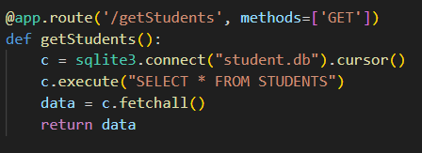
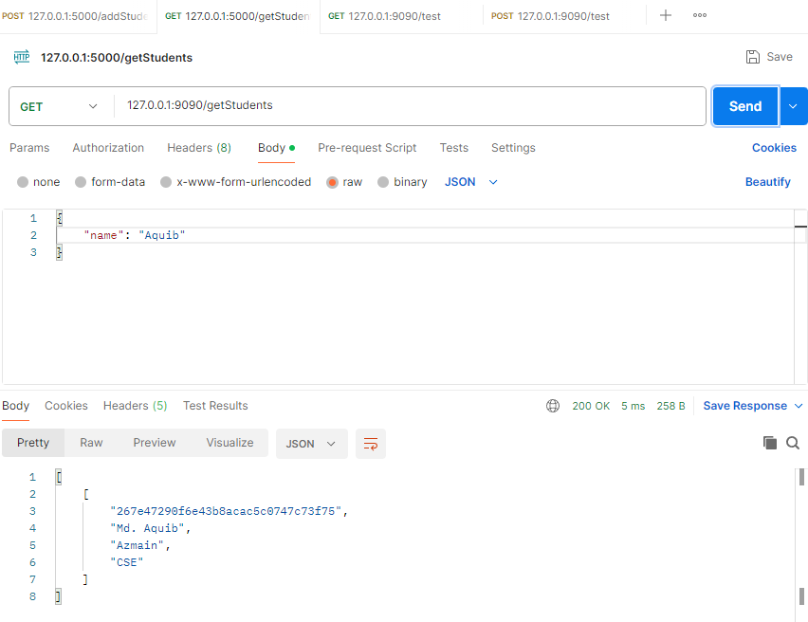

- Endpoint URL: 127.0.0.1:9090/getStudetns
- HTTP Method: Get
- Headers: None
- Body: {“name” : “Aquib”}

